
ISLE of MAN EASTER FESTIVAL of RUNNING
Friday 14th April - Sunday 16th April 2017

Supported by



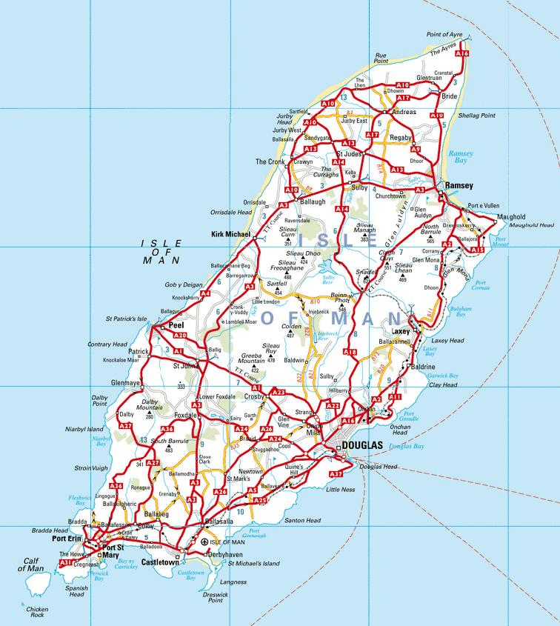
Peel – Saturday Hill Race
Port Erin – Good Friday 10k race
Douglas -
Easter Sunday 5k Women’s race and 5k men’s race.
Sea terminal
Coach Departures – War memorial
The Outback – Sunday lunchtime and Sunday evening prize presentation.

Castletown - airport

Thank you for entering the Isle of Man Easter Festival of Running.
Please read the following information carefully.

Emergency contact telephone number 07624 306698 (7am – midnight during the Easter Festival and 5pm – midnight from 10th – 20th April) Any non-urgent queries can be sent to the Festival email address easterfestival@manx.net

Race Registration

Thursday – Numbers can be collected on Thursday 13th April from the Manx Harriers Clubhouse from 5.30pm – 7pm. This is only for people entered by Tuesday 11th April. There will be no opportunity to enter the festival on Thursday.

Friday – Race registration is at the Rushen FC Clubhouse on Droghadfayle Road, Port Erin. (The coaches drop off here) Race Registration will be open from 16.30 and will close at 18.15. You can collect your race number and make your team declarations (forms available at race registration) no later than 18.15.

Saturday – Race registration is at the House of Manannan in Peel and will be open from 13.00 (The coaches drop off here) There is no need to re-register if you ran on the Friday but you must remember to bring your race number from Friday night. Any replacements will be subject to availability and will cost £5.
Anyone needing to collect their numbers must do so 30 minutes before their race starts.

Sunday – Race Registration is at the Sea Terminal in Douglas and will be open from 9.30am. There is no need to re-register if you ran on the Friday and/or Saturday but you must remember to bring your race number from Friday night. Any replacements will be subject to availability and will cost £5.
Anyone wishing to collect their numbers from race registration must do so 30mins before the race.

Bushys 10k Road Race – Good Friday 14/04/2017

This is the first race of the Festival and is held in the south of the island at Port Erin. The race starts at 18.45 at the breakwater which is about a 10 min walk from race registration. Any local competitors are requested to leave their car in the upper part of the town to avoid clogging up the start area. Give yourself plenty of time to walk down to the start.

You can view a map of the course below:
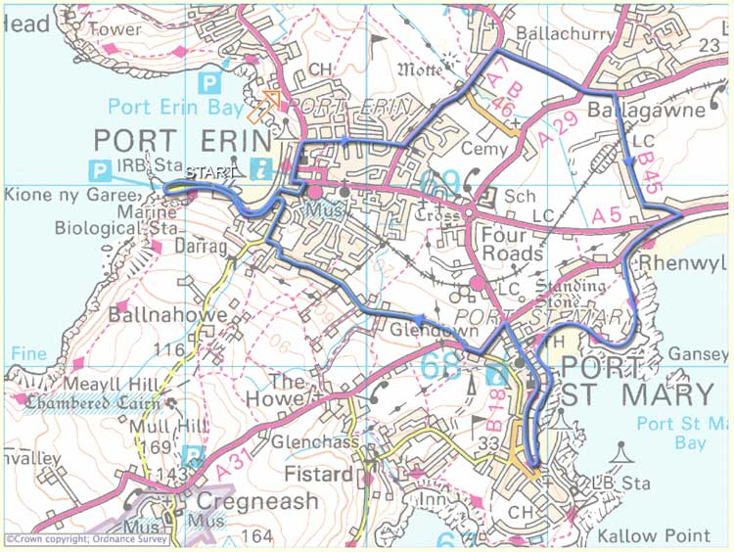

Transport For those who have entered the full festival or paid for coach travel, there is a coach provided to Port Erin leaving Douglas from the War Memorial, Central Promenade, Douglas at 16.30. Coaches will return from Port Erin from the Railway Station car park (close to the drop-off area) at 20.30 and 21.00

Public transport is also available by bus & steam train service if you wish to make your own way down to Port Erin earlier in the day. A bus & rail timetable is available here http://www.iombusandrail.info/

Changing facilities including showers will be available before and after the 10k road race on Good Friday in Port Erin. Local football club Rushen FC are based at Croit Lowey (same location as race registration) about 1200m from the finish of the 10k. Facilities will open at 16.00, and close around 20.00 although they will be locked during the race period. There are also toilets near to the start/finish area.

Refreshments will be available at a number of outlets in Port Erin including the Bay Hotel and Barista Express will be located close to the finish.

Full Factory Winnerswear Peel Hill Race Easter Saturday 15/4/2017

The second race in the Festival is held in the west of the island at Peel approx. 11miles from Douglas. The men’s race starts at 14.15 and the ladies race starts at 15.05 on the road in front of the House of Manannan.
Transport For those who have entered the full festival or paid for coach travel, there is a coach provided to take competitors to Peel leaving Douglas from the War Memorial, Central Promenade at 12.45. The coach will leave Peel from the Creek Inn (by the start/finish area) at 16.30 to return to Douglas.

Changing Facilities – Please arrive ready to run. There are no official changing facilities, although there are temporary toilets available at the start/finish area for Festival runners. Please do not use the toilets in the Creek Inn or House of Manannan.

Refreshments will be available during the afternoon from the cafe located inside the House of Mannanan and in the Creek Inn. Also, after the women’s race has concluded the Creek Inn will be providing free sandwiches to competitors.

Run back to Douglas – Many competitors run back to Douglas, taking in a number of pubs along the way. Please remember that you are ambassadors for the Festival and ensure that you respect the publicans and their pubs.

The Outback Women’s 5k and Men’s 5k Races 16/04/2017

The last race of the festival is a 5km road race for men and a 5km road race for women on an out and back course along Douglas Promenade. Ladies race starts at 10.30hrs & the Men’s race starts at 11.15am
When running keep to the right.
Transport - no transport laid on as Douglas Promenade is within easy access of all Douglas Hotels

Changing Facilities – Please arrive ready to run as there are no official changing facilities. There are toilets at the start/finish area and Sea Terminal (race registration)

Refreshments are available from the open air café serving drinks & light refreshments close to the start/finish as well as a Costa Coffee in the Sea Terminal. At the conclusion of the races, the Outback Sports Bar will be serving free chip baps to all competitors.

Other important information
Age Groups: For junior age groups, the age is at 1st September 2016. Minimum age is 15 for all the festival events. For veterans, age is on the first day of the Festival i.e. 14th April (35 for both men and women).

Numbers: All competitors need to wear their race numbers for all three races.
Timing chips are embedded into your race number. Do not lose or forget your number. Replacements will only be issued if available and in any event a £5 replacement fee will be charged.
Note – any competitors not wearing their official race number, tampering with or mutilating their number will be disqualified and any prize winnings forfeited

Multiple prizes: Any competitors eligible for more than one individual prize in a single race, for example, 10th overall, 2nd veteran, will only be eligible for one prize. The prize awarded will be the one receiving the higher monetary value.

Head phones: These are permitted in the 5K only but must not be worn in the 10K or hill race. Doing so is likely to result in disqualification.

Social Events:

Good Friday – Watch the sunset as you enjoy a post race drink and bar food at the Bay Hotel on Port Erin promenade. There are also a number of other pubs plus café’s and takeaways in Port Erin that will be open during the day and evening.

Easter Saturday – Take a well deserved drink in the harbour side Creek Inn Pub following your efforts in the Hill Race. Some light refreshments will be provided after the races by the Creek Inn Pub.

Easter Sunday – Following your final race please visit the Australian themed sports bar ‘The Outback’ in Douglas 400 metres from the start and finish area of the 5K races. “Chip butties” will be laid on. In the evening the Prize Presentation and Party is also at the Outback. This is definitely a night to remember and not to miss! Under 18’s strictly no admittance. Doors open at 19.00. This is a Private Function and admission is by ticket only. This year the ticket is for your personal use only and is not transferable and ID is required. (DO NOT lose your ticket as it will not be replaced and you will not be able to enter without it)

Beer Drinking Competition – information and rules regarding the 4th leg of the Easter Festival are available on the Facebook page and will be available on the night. Entries close at 20.00 on Sunday. Team declaration forms will be available throughout the festival and on the night. Have a good time but please remember to please drink responsibly.

